**ANY KIND OF GUY**

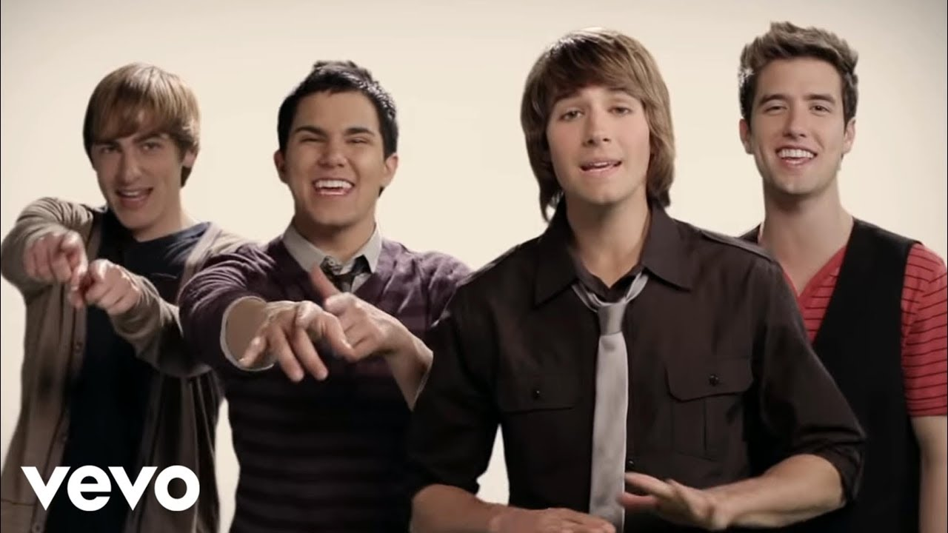

**Big Time Rush**

**Letra**

Hah, yea

B T R, huh huh

Here I am

There you are

Why does it seem so far

Next to you is where I should be (where I wanna be)

Something I

Want so bad

Know what's inside your head

Maybe I could see what you see (tell me what you see)

Gotta keep on believing

That everything takes time

I'll make up any reason

To make you mine

If you're staying or leaving

I'll follow your lead

So why keep pretending

Open your eyes

I can be what you need

Any kind of guy you want, girl

That's the guy I'll be

Turn myself upside down (yes I will, yes I will)

Any kind of guy you want, girl

You know I'll agree

Turn your whole world around (yes I will, yes I will)

Any kind, any kind

Any kind of guy you want

You decide

Change your mind

I will be there

Won't you try

One more try

Be my any kind of girl

You decide

It's alright

I will be there

You seem so hard to know

Say goodbye, say hello

Then you say that it's time to go (now it's time to go)

Changing my point of view

Everyday something new

Anything to get next to you (gonna get to you)

Gotta keep on believing

That everything takes time

I'll make up any reason

To make you mine

If you're staying or leaving

I'll follow your lead

So why keep pretending

Open your eyes

I can be what you need

Any kind of guy you want, girl

That's the guy I'll be

Turn myself upside down (yes I will, yes I will)

Any kind of guy you want, girl

You know I'll agree

Turn your whole world around (yes I will, yes I will)

Any kind, any kind

Any kind of guy you want

You decide

Change your mind

I will be there (I'll be there)

Won't you try

One more try

Be my any kind of girl

You decide

It's alright

I will be there

Let me know if I'm getting through

Making you understand

If it's wrong I'll try something new (try something

New)

Don't look away

Cause I'm here to stay

If it's a game

Then I'm gonna play

Any kind of guy you want, girl

That's the guy I'll be

Turn myself upside down (yes I will, yes I will)

Any kind of guy you want, girl

You know I'll agree

Turn your whole world around (yes I will, yes I will)

Any kind, any kind

Any kind of guy you want

You decide

Change your mind

I will be there (I'll be there)

Won't you try

One more try

Be my any kind of girl

You decide

It's alright

I will be there

Bring it back

Any kind, any kind

Any kind of guy you want

You decide

It's alright

I will be there